

**DEPARTMENT OF COMPUTER SCIENCE**

**SEMESTER 5TH 5A**

**HUMAN COMPUTER INTERACTION**

PROJECT REPORT

ON

**RUNING CUBE**

GROUP MEMBERS

**MONEEB ALAM 16FBSCSM025**

**EHTISHAM ALI 16FBSCSM095**

**SAAD ALI ZAFAR 16FBSCSM077**

**FAISAL AHMED 16FBSCSM062**

**M. YOUSUF ABID 16FBSCSM063**

SUBMITTED TO

**MR. AMEEN CHHAJRO**

Contents

Objective 2

INTRODUCTION 2

TOOLS 2

IMPLEMENTATION 2

DESIGNING 2

PHYSICS 2

CODING 2

GAME INTERFACE 2

CODE 2

**Error! Bookmark not defined.**

CONCLUSION 2

FUTURE WORK 2

# Objective

Our objective is to design a game for entertainment purpose.

# INTRODUCTION

The project “**RUNNING CUBE**” is basically like subway surfer game but the objects which are used in our game is cube. One is cube running and other cubes present in track. If running cube is collide with any cube then it stops and game is over. All the cubes are placed on a plane and plane is used as track. There is two mountains are placed on right and left side of the track. This game is not only entertain adult but also entertain every age of man/woman. This is project is deployed on android and support Cardboard.

# TOOLS

There are two tools which are used in this project:

Unity

Unity is a platform where we develop games, 3D animations and character design etc.

C# visual studio

Visual studio is used to write script for gaming, web development, app development and

# IMPLEMENTATION

## DESIGNING

For game design we used unity. In our project we make cube, plan and mountain as a gaming object.

## PHYSICS

We implemented concepts of physics in our project which are as follow:

* We did friction less environment for track.
* We used force on one cube in order to run that cube.
* We used collision effect on cube.
* We used fog on environment for making attractive interface.

## CODING

For game coding we used C# (Visual Studio 2015).

# GAME INTERFACE

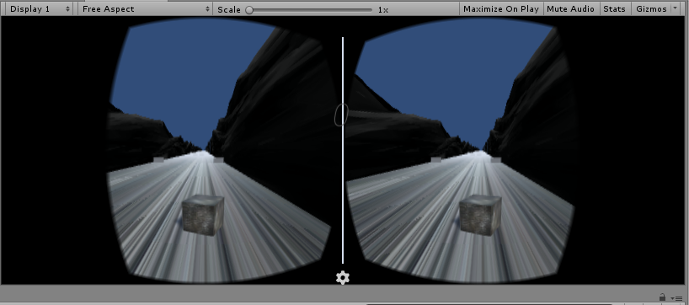

# CODE

We used two scripts for gaming which are as follow:

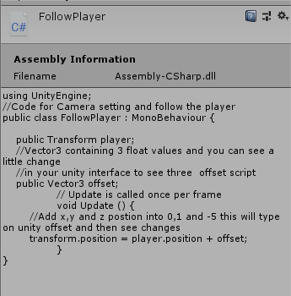

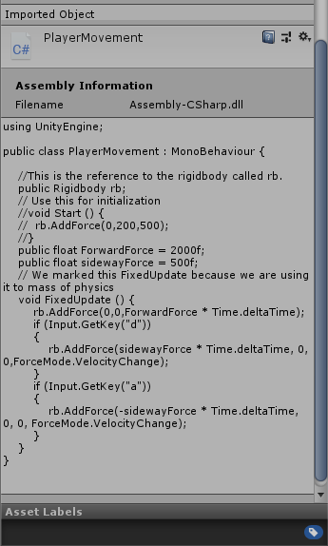

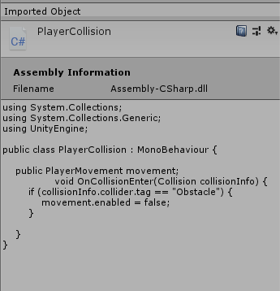

# CONCLUSION

In this project, we learn unity and game coding as well as how to make VR apps or android games. Physics concepts, character designing and coding are used to make a game.

# FUTURE WORK

In future we will change game environment and players, make different kinds of level and score meter.